

APTECH – UNIVERISTY ROAD CENTER

Enviromental Survey

Center Name: | Aptech University Road Center
 | 1st Floor Bell Arcade, Gulistan-e-Johar, Block-1, Main University Road, Opposite University of Karachi., Karachi, Pakistan
Instructor: | Sir Hamza
Group members | Name |  | Student ID
 | M.Maaz Ahmed |  | Student1343020
 | Kashif Ali Khan |  | Student1327884
Project Duration | Start date | 01-Aug-2022
 | End date | 30-Aug-2022

This is to certify that

Mr.:
M.Maaz Ahmed
Kashif Ali Khan

has successfully designed & developed
eProject: Enviromental Survey

Submitted by:
Kashif Ali Khan

Date of issue: 01-Aug-2022

Authorized Signature:

TABLE OF CONTENTS
ACKNOWLEDGE 4
SYNOPSIS 4
ANALYSIS 4
CUSTOMER'S REQUIREMENTS SPECIFICATIONS (CRS) 5
WEBSITE DESIGN 6
SCREENSHOTS ?
SOURCE CODE WITH COMMENTS ?

ACKNOWLEDGE
To have a successful project, it is the continuous effort of many people.
Earliest, we would like to express our appreciation to Aptech University Road Center and E-Project team for giving us a great environment for studying as well as this pleasant project. This is a huge opportunity for us to explore more knowledge, build up problem solving skills and teamwork spirit.
Inside this great organization, thank for Sir Hamza – our teacher, with many years’ experience of teaching, along with enthusiasm as well as rigorous in guiding the project, he is the person who helped us complete the subject to catch the schedule can achieve our goal.
Moreover, we are grateful for having the support from our family, they did create the best conditions for us to focus on the project, and put faith in the dreams we are pursuing.
The finally yet importantly, this is the efforts and curiosity of the members in our group. We have focused on starting the project very early, promoting teamwork by sharing experiences and knowledge with each other throughout the project.

SYNOPSIS
Our client is the educational institute, which wants to enlighten the students of that institute with the precautionary measures related to the environmental protection. So they conduct several seminars, lectures, etc. to the students. They now want to implement some tasks so that the attention of the young generation will be attracted towards taking necessary steps for taking care of the environment, as it relates to the health of the public. They started providing the seminars for free, for the students of the institute and encouraging the students to provide and interactive seminar sessions by visiting to some locations. Also they have started conducting surveys through papers and used to distribute the prizes for the first three students based on the marks secured in the survey and also based on the effective participation in visiting to locations for provided interactive sessions regarding the precautionary measures in protecting the environment. They wanted to reduce the paper consumption for conducting the surveys and want to provide a survey portal where the surveys will be held. So they have approached us to help them in building the survey portal for them.

ANALYSIS
Project Overview:
The project involves creating a survey portal for an educational institute to enhance environmental awareness among students. The institute aims to engage students in taking proactive measures for environmental protection by conducting seminars, interactive sessions, and distributing prizes for participation. The goal is to transition from paper-based surveys to an online survey portal, reducing paper consumption and streamlining the survey process.

Objectives:

Environmental Awareness: The primary objective is to raise environmental consciousness among students by providing interactive sessions and surveys about precautionary measures for environmental protection.

Engagement: The institute intends to attract students' attention and encourage their active participation in seminars, interactive sessions, and surveys through innovative and appealing methods.

Paper Reduction: By transitioning from traditional paper-based surveys to an online survey portal, the institute aims to reduce paper consumption, promoting a more sustainable approach.

Efficiency: The survey portal should streamline the survey distribution, collection, and evaluation processes, making it easier for both students and organizers to manage and participate in surveys.

Project Scope:
The project will involve the following key components:

Survey Portal Development: Design and develop a user-friendly online survey portal that allows students to access surveys, submit responses, and view their results. The portal should support various types of survey questions and provide an intuitive interface.

Interactive Session Integration: Integrate features that enable students to participate in interactive seminar sessions by visiting specific locations. The portal should provide information about upcoming sessions and allow students to register.

Prize Distribution Mechanism: Implement a system to reward students based on their survey participation and effectiveness in attending interactive sessions. Prizes will be awarded to the top three students in both categories.

Admin Dashboard: Develop an administrative dashboard to manage surveys, sessions, student participation, and prize distribution. This will allow organizers to monitor the effectiveness of the program.

Data Security: Ensure that the survey portal is secure, protecting the privacy of student data and survey responses.

Project Considerations:

User Experience (UX): The survey portal should have an intuitive and visually appealing design to encourage student engagement and participation.

Mobile Compatibility: The portal should be responsive and accessible on various devices, including smartphones and tablets, to cater to the students' preferences.

Scalability: The system should be designed to accommodate potential growth in the number of participants, sessions, and surveys.

Data Analytics: Consider incorporating data analytics features to generate insights from survey responses, helping the institute tailor their environmental awareness efforts.

Training and Support: Provide training to institute staff for managing the portal and assist in resolving any technical issues.

Feedback Mechanism: Implement a feedback mechanism for students to provide input on the effectiveness of the interactive sessions and the portal itself.

Conclusion:
The project aims to create a comprehensive survey portal that supports the educational institute's environmental awareness goals. By transitioning from traditional methods to an online platform, the institute can engage students more effectively, reduce paper consumption, and gather valuable data for improving their initiatives. The successful implementation of the survey portal will contribute to the institute's mission of promoting environmental protection among the younger generation while embracing modern technology and sustainable practices.

CUSTOMER'S REQUIREMENTS SPECIFICATIONS (CRS)
Expected delivery date: 1 aug 2023
List of deliverables:
- Document Word.
- User Guide.
- Source code.

HARDWARE/ SOFTWARE REQUIREMENTS:
For webmaster

Hardware
- Intel Pentium 4 processor or higher
- 1 Gigabytes of RAM or higher

Software
- Windows 7 OS or higher
- Visual Studio
- Web browsers such as Chrome or Firefox are recommended.

For web users

Hardware
- Intel Pentium 4 processor or higher
- 512 Megabytes of RAM or higher

Software
- Windows XP OS or higher
- Web browsers such as Chrome or Firefox are recommended.

WEBSITE DESIGN
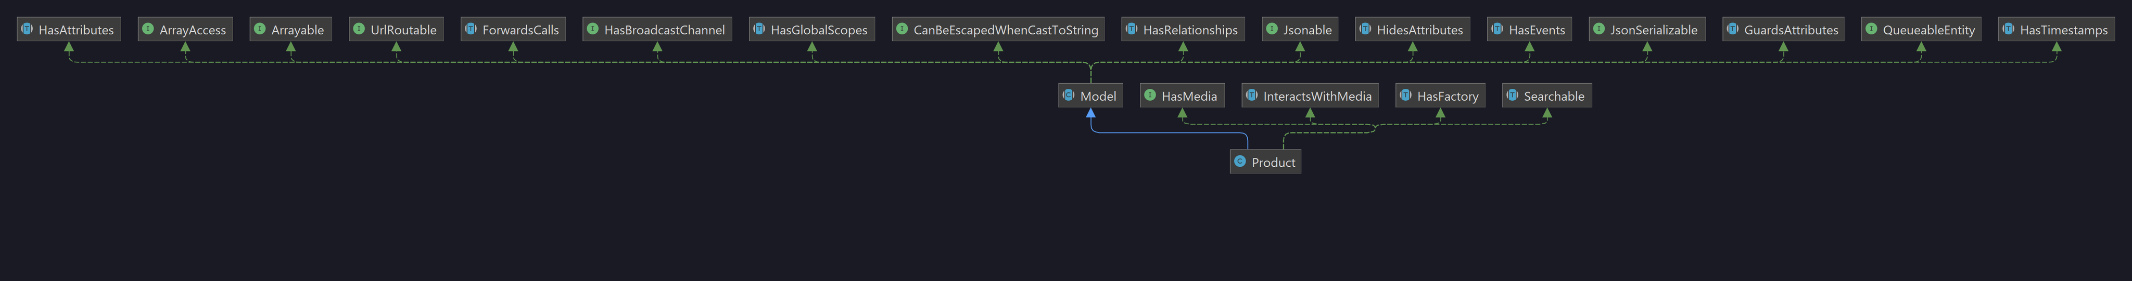

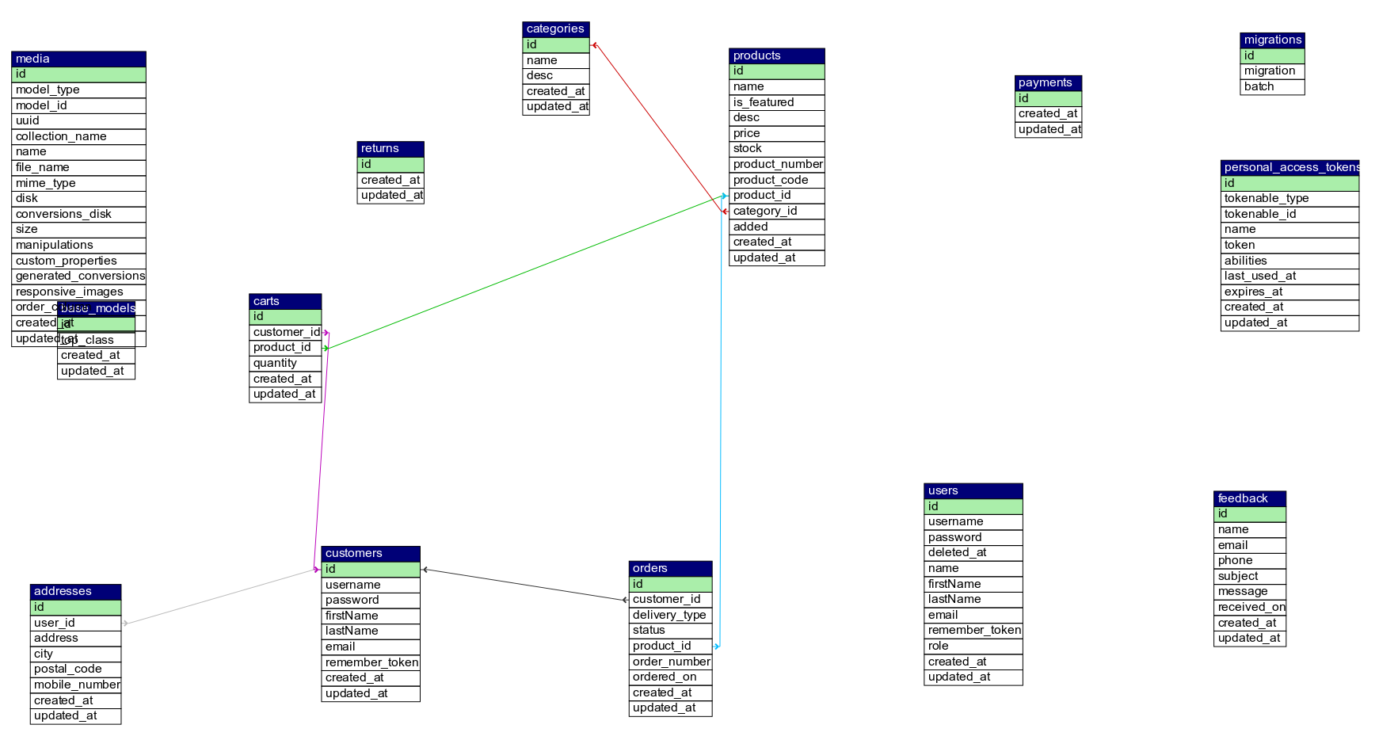

Detailed Website design is given as a separate file in the docs folder as website-design.pdf

SCREENSHOTS
1. Hompage
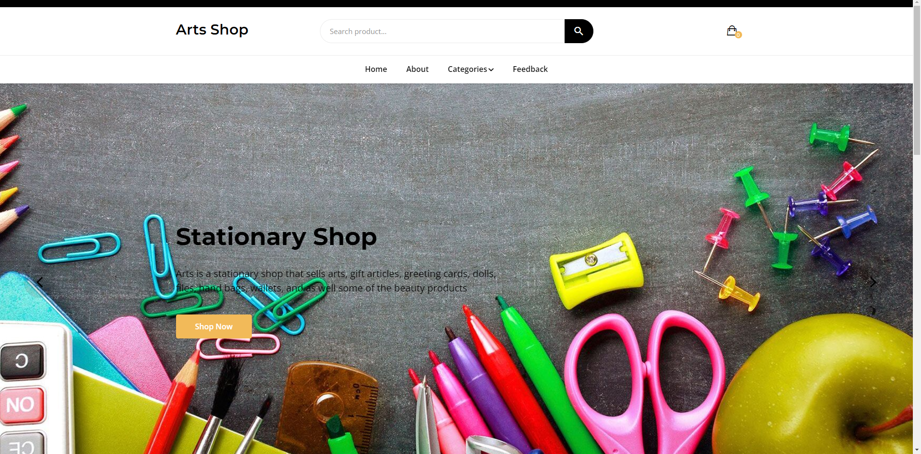
2.Dashboard
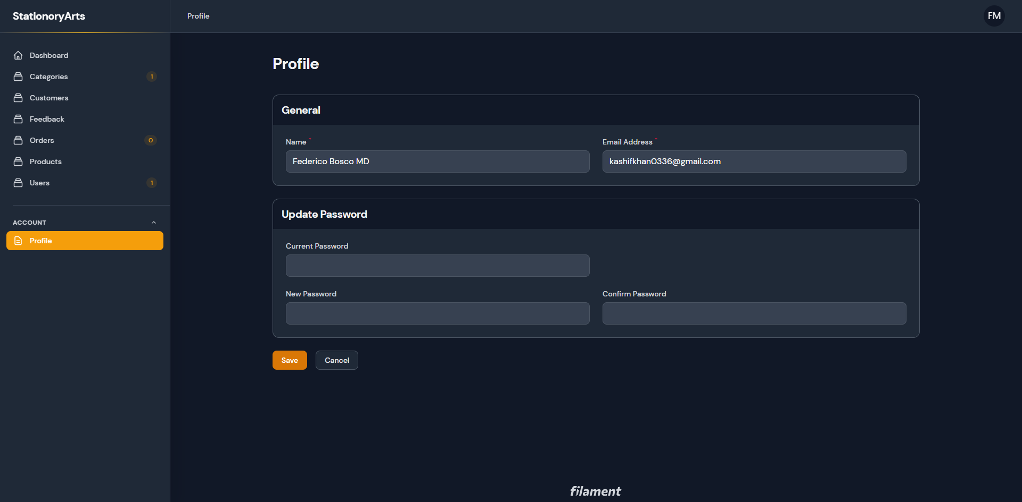
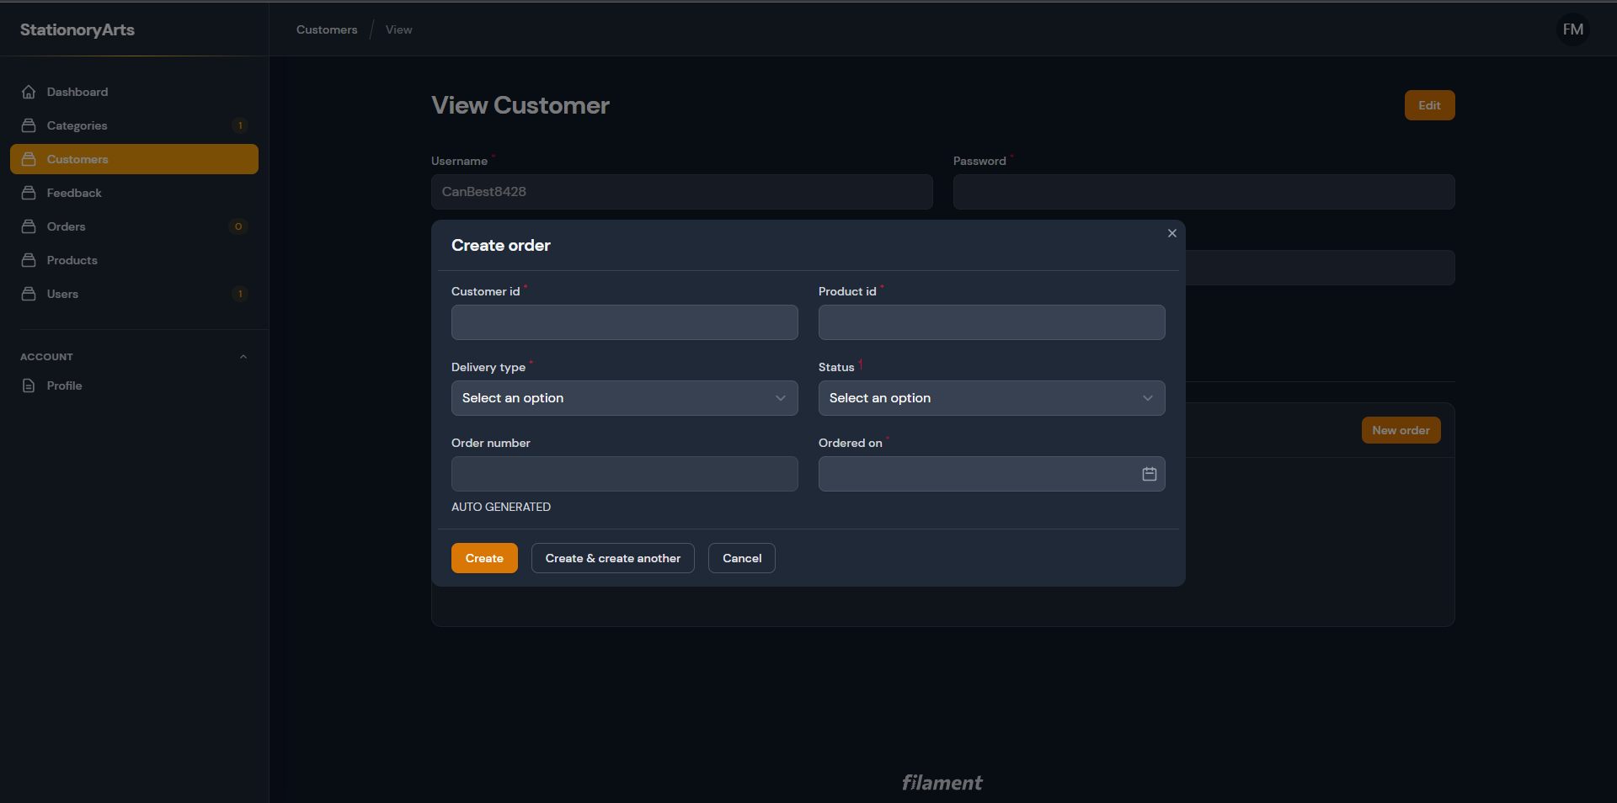
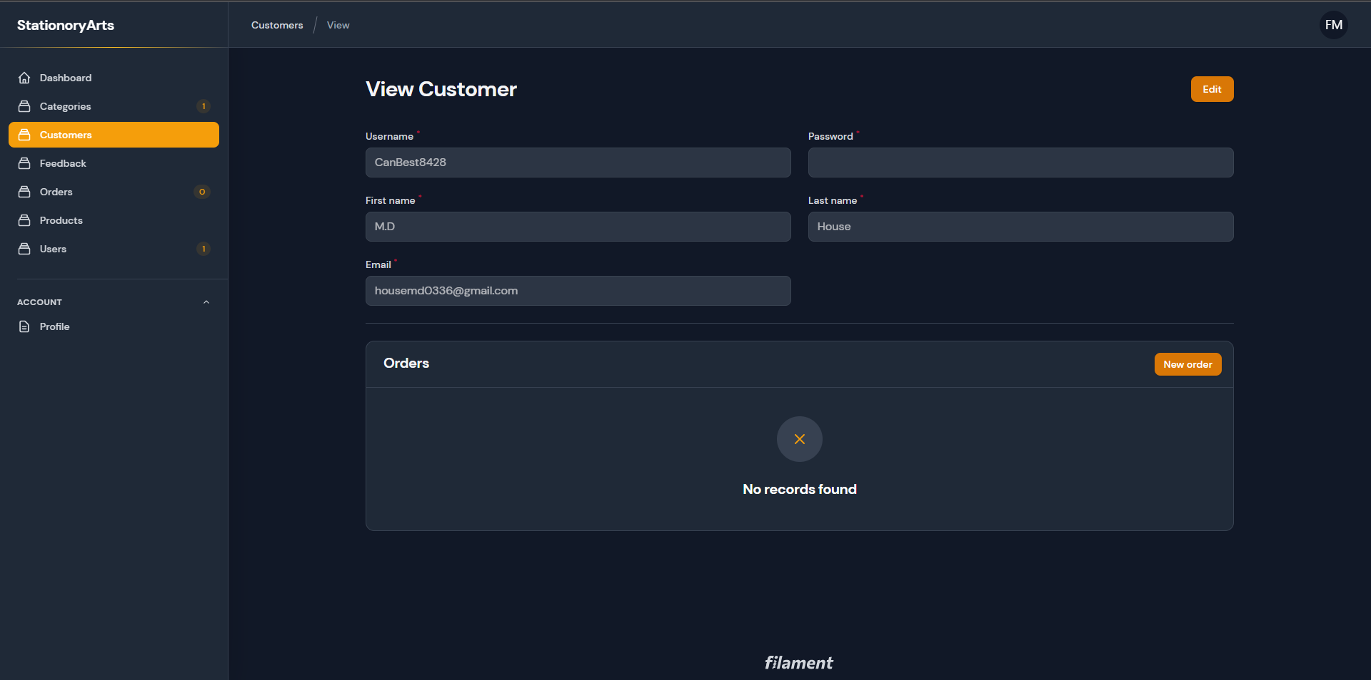

SOURCE CODE WITH COMMENTS
